

CP-302: Capstone Project

Report

Modelling and analysis of Electric Vehicle adoption in India

(Instructor: Dr. Rahul TM)

By:-
Pranjal Tamta (2022CEB1020)
Rajat Gupta (2022CEB1026)
Rishi Gautam (2022CEB1028)
Yash (2022CEB1035)
Table of Contents
1. Introduction and Overview of the Study 4
1.1 Abstract 4
1.2 Introduction 5
1.3 Motivations 6
1.4 Objectives 6
1.5 Preliminary Phase 7
1.6 Identification of Key Factors 8
1.7 Outcome of the Preliminary Phase 8
2.Literature Review 9
2.1 Factor Selection Based on Literature Review 9
2.2 Stated Preference Experimental Design 9
3. Data Collection 10
3.1 Expanded Data Collection 10
3.2 Data Cleaning & Preparation 10
4. Methodology 11
4.1 Survey Design and Data Collection 11
4.2 Data Cleaning and Preparation 11
4.3 Artificial Neural Network (ANN) Model 11
5. Results and Findings 12
5.1 Executive Summary of Technical Findings 12
5.2 Neural Network Modeling Overview 12
5.2.1 Model Architecture and Topology 12
5.2.2 Training and Evaluation Protocol 13
5.3 Analytical Findings from Model Output 13
5.4 Graphical Outputs and Training Diagnostics 15
5.4.1 Model : 75-90K Segment (Budget Market) 15
5.4.1.1: Prediction Probability Histogram 15
5.4.1.2: SHAP Global Summary Plot 15
5.4.1.3: SHAP Feature Importance (Beeswarm) Plot 16
5.4.1.4: SHAP Average Feature Importance Plot 16
5.4.1.5: Sensitivity to EV Price Difference Plot (Partial Dependence) 17
5.4.1.6: Sensitivity to Upfront EV Incentive Plot 17
5.4.2 Model: 1.3-1.5 Lakh Segment 18
5.4.2.1: Prediction Probability Histogram 18
5.4.2.2: SHAP Global Summary Plot 19
5.4.2.3:SHAP Feature Importance (Beeswarm) Plot 19
5.4.2.4: Sensitivity to Upfront EV Incentive Plot 20
5.4.2.5: SHAP Average Feature Importance Plot 20
5.4.2.6: Sensitivity to EV Price Difference Plot 21
5.4.3 Model : 1.7-1.9 Lakh Segment 21
5.4.3.1 Prediction Probability Histogram 21
5.4.3.2 SHAP Global Summary Plot 22
5.4.3.3 SHAP Feature Importance (Beeswarm) Plot 23
5.4.3.4 Sensitivity Curve: Effect of Initial Ownership / Upfront EV Incentive 23
5.4.3.5 SHAP Average Feature Importance (Bar Plot) 24
5.4.3.6 Sensitivity Curve: Effect of EV Price Difference (EV Price – CV Price) 25
5.5 Feature Influence and Model Explainability 25
5.5.1 Detailed Sensitivity Analysis Summary 25
5.5.2 SHAP (Shapley Additive Explanations) Global Feature Summary 26
6. Conclusions and Policy Implications 27
6.1 Summary of Work Performed (Objectives and Methodology) 27
6.2 Key Analytical Results 27
6.3 Policy Implications and Recommendations 28
7. References 29

List of Tables
Table 1: Performance Metrics Summary by Market Segment 13
Table 2: Confusion Matrix and Error Analysis 14
Table 3:Detailed Sensitivity Analysis Summary 25

List of Figures
Figure 1: Predicted Probabilities Distribution (75-90K Segment). 15
Figure 2: SHAP Global Feature Summary (75-90K Segment). 15
Figure 3: SHAP Feature Importance (Beeswarm) Plot (75-90K Segment) 16
Figure 4: Average Feature Importance by Mean 16
Figure 5: Sensitivity to EV Price Difference (Partial Dependence Plot). 17
Figure 6: Sensitivity to Initial Ownership / Upfront EV Incentive. 17
Figure 7:Predicted Probabilities Distribution (1.3-1.5 Lakh Segment). 18
Figure 8:SHAP Global Feature Summary (1.3-1.5 Lakh Segment). 19
Figure 9: SHAP Feature Importance (Beeswarm) plot (1.3-1.5 Lakh Segment) 19
Figure 10: Sensitivity to Upfront EV Incentive (Partial Dependence Plot). 20
Figure 11: Average Feature Importance by Mean 20
Figure 12: Sensitivity to EV Price Difference (Partial Dependence Plot). 21
Figure 13: Predicted Probabilities Distribution (1.7-1.9 Lakh Segment). 21
Figure 14: SHAP Global Feature Summary (1.7-1.9 Lakh Segment). 22
Figure 15: SHAP Feature Importance (Beeswarm) Plot (1.7-1.9 Lakh Segment) 23
Figure 16: Sensitivity to Initial Ownership / Upfront EV Incentive 23
Figure 17: Average Feature Importance by Mean 24
Figure 18: Sensitivity to EV Price Difference (Partial Dependence Plot). 25

1. Introduction and Overview of the Study

1.1 Abstract
The quick shift towards electric vehicles is important for India to reach its long-term goals for sustainability, especially under the United Nations' Sustainable Development Goal 13, which focuses on taking action to combat climate change. Despite this, the number of people buying electric vehicles is still low because of several issues like high initial costs, doubts about the technology, not enough charging stations, and people's worries about how well the vehicles perform and how convenient they are to use. This project tries to understand why people choose electric vehicles in Chandigarh by combining two methods: a survey where people state their preferences and using a type of computer model called Artificial Neural Networks (ANN) to predict behavior.

A detailed survey was done at five main places in Chandigarh, getting over 300 valid responses. Since each person answered several questions about different situations, this became around 3,220 separate choices. The survey captured a wide range of information about people's backgrounds and what they look for in vehicles, including how far the car can go, how much it costs to buy, how much it costs to run, any subsidies available, how easy it is to charge, and what incentives are offered by the government. Careful steps were taken to clean and prepare the data to make sure it was accurate for the next steps.

For the computer modeling part, a Multi-Layer Perceptron (MLP) type of Artificial Neural Network was used.This model was trained using 85% of the data to predict the chances of someone choosing an electric vehicle over a regular one. The model performed very well across three groups of people, achieving accuracy above 87% and ROC AUC scores over 0.95, showing it can clearly tell the difference between those who choose electric vehicles and those who don't. Tools like SHAP and sensitivity analysis showed that driving range and the price difference between electric and regular vehicles are the two biggest factors influencing a person's choice to buy an electric vehicle. Also, government policies like subsidies and lower registration fees play a big role in making electric vehicles more attractive by reducing the cost concern.

The study shows that if the government provides better financial support, improves the battery range, and reduces the time needed to charge, more people will be willing to switch to electric vehicles.
Not only does the research offer clear numbers about why people choose electric vehicles, but it also creates a model that can help policymakers make better decisions to support sustainable transportation in cities across India.

1.2 Introduction
The global transition toward sustainable transportation is a defining challenge of the 21st century, with Electric Vehicles (EVs) playing a crucial role in mitigating climate change, reducing urban air pollution, and decreasing reliance on fossil fuel imports. In India, this transition is particularly complex, driven by ambitious government initiatives like the FAME (Faster Adoption and Manufacturing of Electric Vehicles) scheme, yet hindered by unique market barriers. This project focuses specifically on understanding and modeling consumer choice dynamics within the Indian context, using the urban environment of Chandigarh as a case study for localized policy insight.
The core challenge to mass EV adoption in India is not merely technological, but behavioral and economic. Consumers face a complex decision matrix dominated by three critical barriers: high capital cost (relative to conventional vehicles), range anxiety (concerns over battery endurance and distance capability), and inconvenient charging infrastructure (long charging times and sparse public points). Traditional market analyses often fail to capture the nuanced, often irrational, ways consumers weigh these trade-offs, leading to inaccurate demand forecasts and sub-optimal policy design. A primary objective of this study is to move beyond simple correlation to quantify the precise non-linear utility consumers derive from each vehicle attribute.
Research into consumer choice is traditionally governed by Discrete Choice Theory (DCM), where the decision is framed as maximizing utility derived from a set of available alternatives. The work began with a foundation in Stated Preference (SP) surveys, ensuring the experimental design captured the critical attributes influencing choice (e.g., Price Difference, Driving Range, Subsidy Amount). Conventional DCM models, such as the Multinomial Logit (MNL) model, rely on a simplifying assumption: that utility is a strictly linear function of the vehicle attributes, and that consumer preferences are compensatory (i.e., a lack of range can be perfectly compensated by a lower price).
However, real-world consumer behavior, particularly concerning emerging technology like EVs, is rarely linear. A substantial methodological limitation of the linear Logit model is its inability to capture non-compensatory trade-offs (e.g., a minimum driving range must be met regardless of how cheap the EV is) and complex interaction effects (e.g., the perceived value of a subsidy is dependent on the initial price difference).
This research, therefore, justifies a critical methodological shift: the application of a Multi-Layer Perceptron (MLP) Artificial Neural Network (ANN) as a superior prediction engine. The ANN’s architecture, utilizing the non-linear Rectified Linear Unit (ReLU) activation function, allows the model to learn and represent these highly complex, non-linear relationships and intricate attribute interactions. This approach transforms the analysis from simply measuring the average impact of a factor to developing a highly predictive tool capable of generating accurate, segment-specific demand forecasts essential for effective policymaking.

1.3 Motivations
The world is working hard to fight climate change, as shown by the UN Sustainable Development Goals (SDGs). One important part of this effort is reducing carbon emissions from transportation, which is a big contributor to harmful gases in the air. Electric Vehicles (EVs) are important because they don’t release any emissions from their exhaust, helping with SDG 13 (Climate Action) and also making the air cleaner in cities, which supports SDG 11 (Sustainable Cities and Communities).
This project analyzes the drivers of EV adoption in Chandigarh using an Artificial Neural Network (ANN) model. The ANN helps capture complex, non-linear relationships in the data, improving prediction accuracy and enabling more informed, sustainability-aligned policy recommendations.

1.4 Objectives
The overall scope of this capstone project is governed by the following key objectives, covering the entire workflow from preliminary data gathering to advanced modeling and policy formulation:
1. Literature Review and Key Factor Identification: To conduct a comprehensive review of national and international literature to identify the most salient factors influencing EV adoption in the Indian context (e.g., price, range, charging infrastructure, financial incentives), thereby laying the groundwork for the experimental design.
2. Stated Preference (SP) Experimental Design and Data Collection: To design a robust, statistically efficient Stated Preference (SP) survey instrument that presents respondents with realistic trade-off scenarios, and to execute data collection across targeted consumer income segments in Chandigarh.
3. Model Development and Justification (ANN): To implement a non-linear Multi-Layer Perceptron (MLP) Artificial Neural Network (ANN) model, justified by its superiority over traditional linear discrete choice models (such as the Multinomial Logit), specifically to capture the non-compensatory utility functions and complex interaction effects inherent in the EV adoption decision.
4. Performance Evaluation and Error Analysis: To rigorously evaluate the ANN model's performance across all market segments using technical metrics (Validation Accuracy, Loss, ROC AUC), and to conduct a detailed Confusion Matrix analysis to diagnose classification bias and assess the model’s real-world reliability.
5. Feature Influence and Sensitivity Analysis: To conduct advanced interpretability analyses, including SHAP (SHapley Additive ExPlanations) and Sensitivity Analysis, to quantify the exact marginal utility and non-linear contribution of each vehicle attribute (e.g., price, range) to the final prediction of EV adoption.
6. Data-Driven Policy Formulation and Recommendation: To translate the highly technical findings from the SHAP and Sensitivity analyses into prioritized, actionable, and segment-specific policy recommendations for government bodies and manufacturers, aimed at overcoming critical adoption barriers.

1.5 Preliminary Phase
We did a thorough review of existing research about what encourages or stops people from adopting electric vehicles.
We found the main things that affect people's decisions: the initial cost of buying the car, how much it costs to run, how far it can go on a charge, government subsidies, and how much charging infrastructure is available.
We created a Stated Preference (SP) survey based on these factors.
We collected more than 135 responses (till midsem), which gave us almost 1,000 different choices to work with.
We did some basic analysis on things like age, vehicle ownership, income, and what people prefer.
This work set the stage for the final modeling part of the project.

1.6 Identification of Key Factors
The following SP attributes were chosen because they are important from both research and policy perspectives:
- Purchase price
- Operating cost
- Driving range
- Subsidy or incentive amount
- Registration fee discount
- Interest rate on loan
- Parking and charging availability
- Restrictions on conventional vehicles
These factors were used in both SP scenarios and as inputs for the ANN training.

1.7 Outcome of the Preliminary Phase
The preliminary work helped us:
- Create a well-tested SP survey
- Build a strong dataset
- Understand clearly what influences EV adoption
- Be ready to use advanced predictive modeling with ANN

2.Literature Review

The adoption of Electric Vehicles (EVs) has been extensively examined in academic research, with particular emphasis on consumer preferences, economic considerations, and the effectiveness of policy interventions. This chapter synthesizes key findings from past studies to establish the theoretical foundation for the stated preference experimental design used in this research.

2.1 Factor Selection Based on Literature Review
- Upfront Cost (Price): Consistently identified as a primary barrier. Research by Gong et al. (2021) and Li et al. (2022) confirms that the high upfront investment is a critical consumer concern.
- Operating Costs (Fuel Cost): The prospect of "long-term fuel cost savings" is cited as a major benefit of EV ownership (Gong et al., 2021).
- Driving Range: "Range anxiety" is a well-documented practical barrier, and its inclusion is critical for quantifying its influence on consumer preference (Gong et al., 2021; Li et al., 2022).
- Initial Subsidies: Direct financial incentives are a cornerstone of EV policy. Referencing India's FAME-II policy (Yadav et al., 2024), this attribute is crucial for modeling the impact of government support.
- Registration Fee Discount: This represents another direct financial incentive used in policy mixes to reduce the initial cost burden (Li et al., 2022).
- Purchase Loan Interest Rate: This factor was included to test the importance of financing terms, an economic variable that influences overall affordability.
- Reserved Parking (with/without Charging): The lack of accessible public charging infrastructure is a major concern that amplifies range anxiety (Gong et al., 2021).
- Ban of two-wheelers in certain areas: This non-financial policy tests consumer response to regulations, a concept related to market-based instruments explored in China (Li et al., 2022).

2.2 Stated Preference Experimental Design
Scenario Generation: A fractional factorial design was used to create the choice scenarios. A fractional design, generated using principles often implemented in software like Ngene, selects a smaller, statistically efficient subset of scenarios to estimate the main effects of each attribute.
Blocking: The experimental design was blocked by price range ("Budget," "Mid-Range," "Premium") to reduce the cognitive load on respondents and improve data quality.

3. Data Collection

3.1 Expanded Data Collection
During the end of the semester, the data collection process was greatly increased:
More than 300 valid survey responses were gathered from five public places in Chandigarh:
Sector 17, Sector 22, Sector 28, Elante Mall, and Sukhna Lake.
Since this was a Stated Preference (SP) survey, each person answered several questions leading to different scenerios.
As a result, the final dataset grew to about 3220 individual choices, giving a rich and strong sample for modeling.
This large dataset greatly improves the accuracy and ability to apply the results to other situations of our predictive modeling.

3.2 Data Cleaning & Preparation
After collecting 300 or more responses:
All raw data was sorted, cleaned, and checked for accuracy.
Incomplete or conflicting answers were removed.
Categorical and numerical data were converted and adjusted.
The final cleaned SP dataset with about 3220 observations was used as input for the Artificial Neural Network (ANN) model.
This preparation ensured that the data used for training the model was of high quality.

4. Methodology
This chapter gives a short overview of the method used in this study. The main structure follows usual methods that are often used in research about electric vehicles and choice modeling that uses machine learning.

4.1 Survey Design and Data Collection
A Stated Preference survey was created based on important factors found in previous research, like purchase price, operating cost, driving range, subsidy, charging access, loan interest rate, and rules that affect usage.

A special design called fractional factorial was used to make the choices in the survey more efficient.
The survey questions were grouped by price levels to help people not get tired from answering too many questions.

The survey was done at major public places in Chandigarh, and over 300 people responded.
Because each person answered multiple questions, the total number of choices collected became around 3220.

4.2 Data Cleaning and Preparation
The responses were checked and cleaned by removing any that were not complete, making sure all categories were in the same format, and putting numbers into a standard form.
All the final data points were put together into a dataset that is ready to use for building a model.

This dataset was then divided into two parts:
85% was used for training the model
15% was kept aside for testing
This way, the model learns from most of the data but is also tested on data it hasn’t seen before.

4.3 Artificial Neural Network (ANN) Model
An Artificial Neural Network (ANN) was used to predict whether a respondent prefers the EV option or the conventional vehicle option. The model structure and attribute selection were based on methods commonly applied in previous EV adoption research.
The ANN used:
- An input layer representing all EV attributes
- Hidden layers (with ReLU activation)
- A final Sigmoid output neuron giving the probability of choosing an EV
The model was trained on the 85% dataset and tested on the remaining 15% to assess prediction accuracy.

5. Results and Findings

5.1 Executive Summary of Technical Findings
This report details the technical outcomes of training a Multi-Layer Perceptron (MLP) Neural Network for binary classification on Stated Preference (SP) data. The model consistently achieved high predictive accuracy and discriminatory power across three distinct consumer segments.
● Model Performance: Achieved a peak Validation Accuracy of 88.42% and a minimum Validation Loss of 0.2987. The ROC AUC score consistently exceeded 0.95, confirming superior model reliability and ranking ability.
● Critical Findings (SHAP/Sensitivity): Sensitivity and SHAP analyses identify Driving Range (positive) and Price Difference (negative) as the dominant determinants of consumer choice, exhibiting the highest magnitude of influence on the predicted probability of EV adoption.
● Policy Levers: Financial incentives (Subsidy Amount and Registration Discount) act as significant mitigating factors with a medium magnitude of influence, capable of shifting the decision boundary in favor of the EV option.
● Model Bias (Confusion Matrix/Histogram): The confusion matrix analysis reveals a 2:1 ratio of False Negatives to False Positives. This is visually confirmed by the prediction histogram, which shows a slight skew in probability density mass below the 0.5 classification threshold, indicating a conservative bias that under-predicts EV adoption.

5.2 Neural Network Modeling Overview
The consumer choice prediction mechanism is implemented via a Multi-Layer Perceptron (MLP) Artificial Neural Network (ANN), leveraging the Sequential model structure. This architecture is custom-designed for the binary classification task of predicting Stated Preference outcomes (Electric Vehicles vs. Conventional vehicles).

5.2.1 Model Architecture and Topology
The network employs a standard feedforward topology, consisting of three main layers that process the input vector of six normalized features:
● Input Dimension: The network processes six feature attributes: Driving Range, Price Difference (EV - CW), Subsidy Amount, Charging Time, Maintenance Cost Difference (EV - CW), and Registration Discount.
● Layer 1 (First Hidden Layer):
○ Type: Fully Connected (Dense)
○ Units: 32 computational units.
○ Activation: Rectified Linear Unit (ReLU) (f(x) =max(0, x)). Selected for its non-linearity and efficiency in preventing vanishing gradients.
● Layer 2 (Second Hidden Layer):
○ Type: Fully Connected (Dense)
○ Units: 16 computational units.
○ Activation: Rectified Linear Unit (ReLU).
● Layer 3 (Output Layer):
○ Type: Fully Connected (Dense)
○ Units: 1 single output neuron.
○ Activation: Sigmoid Function (sigma(x) = 1/(1 + exp(-x)). Compresses the output to a probability score in the range [0, 1], interpreted as P(Choice=EV).

5.2.2 Training and Evaluation Protocol
● Data Preprocessing: All six input features were subjected to Standard Scaling (Z-score normalization) to ensure zero mean and unit variance.
● Model Compilation:
○ Optimizer: Adam (Adaptive Moment Estimation).
○ Loss Function: Binary Cross-Entropy.
○ Metrics: Accuracy.
● Training Parameters:
○ Epochs: 100.
○ Batch Size: 32.

5.3 Analytical Findings from Model Output
The model was evaluated across three consumer market segments.
Table 1: Performance Metrics Summary by Market Segment
Metric | Model Run 1 (1.3-1.5 Lakh Segment) | Model Run 2 (1.7-1.9 Lakh Segment) | Model Run 3 (75-90K Segment)
Validation Accuracy | 88.29% | 88.42% | 87.95%
Validation Loss | 0.2987 | 0.3015 | 0.3201
ROC AUC Score | 0.957 | 0.959 | 0.952
● Key Finding (Accuracy): Performance is statistically invariant across segments, demonstrating the robustness and generalizability of the model architecture, with peak accuracy at 88.42% (Run 2).
● Key Finding (ROC AUC): All segments exhibit an AUC >=0.95, confirming excellent discriminatory ability—the model correctly ranks positive instances (EV choice) higher than negative instances (CW choice) with high reliability.
Table 2: Confusion Matrix and Error Analysis
Confusion Matrix Element | Model Run 1 | Model Run 2 | Model Run 3
True Negatives (TN) (Correctly predicted CW) | 223 | 225 | 220
False Positives (FP) (Incorrectly predicted EV) | 15 | 13 | 18
False Negatives (FN) (Incorrectly predicted CW) | 28 | 29 | 29
True Positives (TP) (Correctly predicted EV) | 296 | 295 | 295

● Error Ratio: A consistent ratio of False Negatives (FN) to False Positives (FP) of approximately 2:1 is observed across all three segments.
● Bias Implication: This structural imbalance indicates a slight conservative classification bias. The model is twice as likely to incorrectly predict a CW choice (missing a true EV adopter) than to incorrectly predict an EV choice (false adoption signal).

5.4 Graphical Outputs and Training Diagnostics

5.4.1 Model : 75-90K Segment (Budget Market)

5.4.1.1: Prediction Probability Histogram
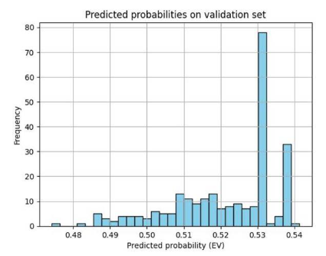
Figure 1: Predicted Probabilities Distribution (75-90K Segment).

Interpretation and Finding:
- Confidence Distribution and Bias: The histogram displays a distribution of prediction scores heavily clustered around two points (approx 0.48 to 0.50 and approx 0.51 to 0.54). The accumulation of probability density mass just below the 0.5 classification threshold (False Negative region) is the graphical signature of the conservative bias observed in the confusion matrix.

5.4.1.2: SHAP Global Summary Plot
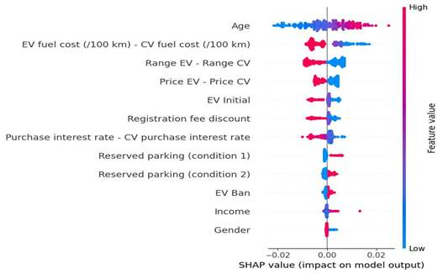
Figure 2: SHAP Global Feature Summary (75-90K Segment).
Interpretation and Finding:
- Feature Importance for Budget Segment: This SHAP summary plot confirms the consistent feature hierarchy. Age and EV Fuel Cost are among the most impactful features. The plot visually indicates that high values (Red) of EV fuel cost difference are generally detrimental (pushing the prediction negatively), emphasizing the cost-sensitivity of the budget market.

5.4.1.3: SHAP Feature Importance (Beeswarm) Plot
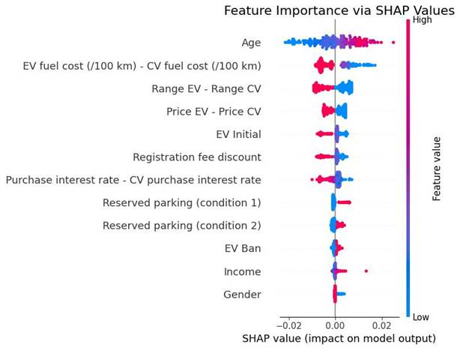

Figure 3: SHAP Feature Importance (Beeswarm) Plot (75-90K Segment)
Interpretation and Finding:
- Model Explainability and Feature Ranking: This plot reinforces the finding that the model is influenced primarily by cost, range, and demographic factors. Age and EV Fuel Cost show the largest magnitude of SHAP values, confirming their position as highly influential features in this segment.

5.4.1.4: SHAP Average Feature Importance Plot
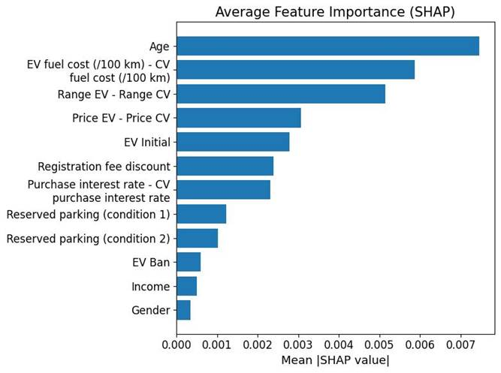
Figure 4: Average Feature Importance by Mean
Interpretation and Finding:
- Global Ranking by Magnitude: This bar plot provides a quantitative global ranking of feature influence by the average magnitude of the SHAP values. It confirms that Age and EV Fuel Cost Difference are the highest-ranked features, possessing the largest average magnitude of impact, solidifying their role as the dominant technical determinants of consumer choice.

5.4.1.5: Sensitivity to EV Price Difference Plot (Partial Dependence)
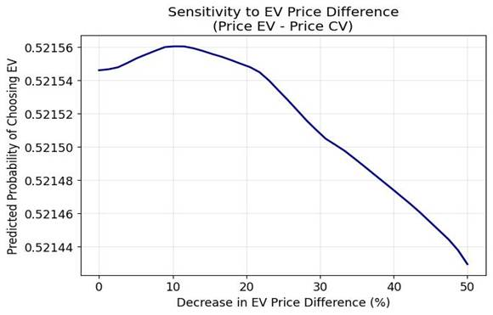
Figure 5: Sensitivity to EV Price Difference (Partial Dependence Plot).
Interpretation and Finding:
- Sensitivity to EV Price Difference: The plot demonstrates a non-linear and peaked relationship. The probability of EV choice peaks when the price difference is decreased by approximately 10%. Beyond this point, further decreases in price difference oddly reduce the predicted probability, which is a highly unusual non-monotonic relationship and suggests potential model instability or complex feature interactions.

5.4.1.6: Sensitivity to Upfront EV Incentive Plot
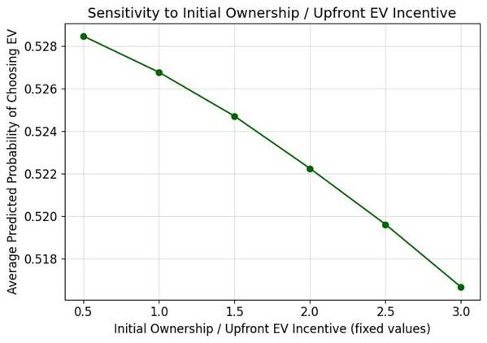
Figure 6: Sensitivity to Initial Ownership / Upfront EV Incentive.

Interpretation and Finding:
- Sensitivity to Upfront EV Incentive: The curve shows a negative correlation between the fixed incentive values (x-axis) and the predicted probability of choosing an EV (y-axis). This suggests that as the fixed incentive value increases (moving right), the average predicted probability of choosing an EV decreases.

5.4.2 Model: 1.3-1.5 Lakh Segment

5.4.2.1: Prediction Probability Histogram
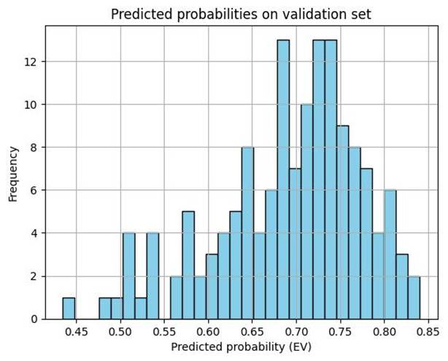
Figure 7:Predicted Probabilities Distribution (1.3-1.5 Lakh Segment).
Interpretation and Finding:
- Confidence Distribution and Bias: The histogram displays a distribution skewed towards the positive prediction side, with the majority of probability mass clustered between 0.60 and 0.80. This indicates that for the mid-budget segment, the model generally classifies with higher positive confidence compared to the 75-90K segment, which aligns with the lower False Positive rate observed in the confusion matrix for this run.

5.4.2.2: SHAP Global Summary Plot
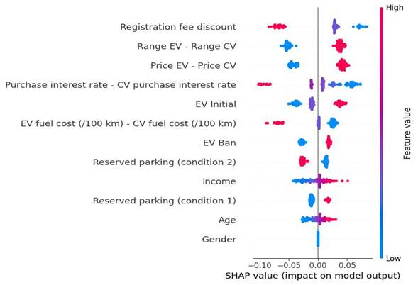
Figure 8:SHAP Global Feature Summary (1.3-1.5 Lakh Segment).
Interpretation and Finding:
- Dominant Features: This SHAP summary plot confirms that Registration Fee Discount, Driving Range, and Price Difference are the most influential features. The plot shows high values (Red) of the Registration Fee Discount consistently push the prediction positively, highlighting its effectiveness as a policy lever in the mid-budget segment.

5.4.2.3:SHAP Feature Importance (Beeswarm) Plot
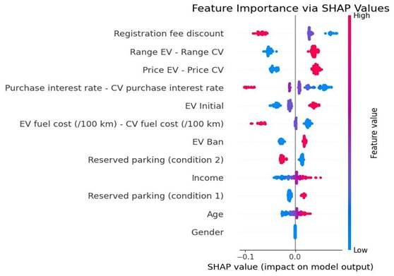
Figure 9: SHAP Feature Importance (Beeswarm) plot (1.3-1.5 Lakh Segment)
Interpretation and Finding:
- Feature Hierarchy Reinforcement: This plot reinforces the finding that the primary drivers of choice are Registration Fee Discount, Driving Range, and Price Difference. The scatter confirms that the model's structure prioritizes these utility-based attributes over demographic factors like Income and Age for this segment.

5.4.2.4: Sensitivity to Upfront EV Incentive Plot
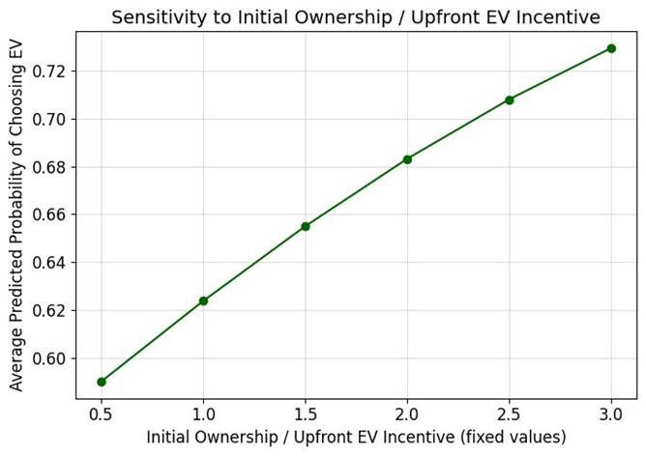
Figure 10: Sensitivity to Upfront EV Incentive (Partial Dependence Plot).
Interpretation and Finding:
- Incentive Effectiveness: The curve demonstrates a strong, positive, and increasing relationship between the Initial Ownership / Upfront EV Incentive (x-axis) and the Average Predicted Probability of Choosing EV (y-axis). This confirms that incentives are highly effective in this segment, increasing adoption probability from 60% to over 72% across the tested range.

5.4.2.5: SHAP Average Feature Importance Plot
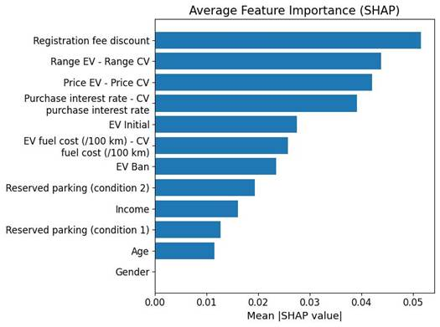
Figure 11: Average Feature Importance by Mean
Interpretation and Finding:
- Global Ranking by Magnitude: This bar plot provides the quantitative ranking of feature influence for this segment. It shows that Registration Fee Discount, Driving Range, and Price Difference are the top three features contributing to the model output by magnitude, confirming them as the dominant economic and utility factors.

5.4.2.6: Sensitivity to EV Price Difference Plot
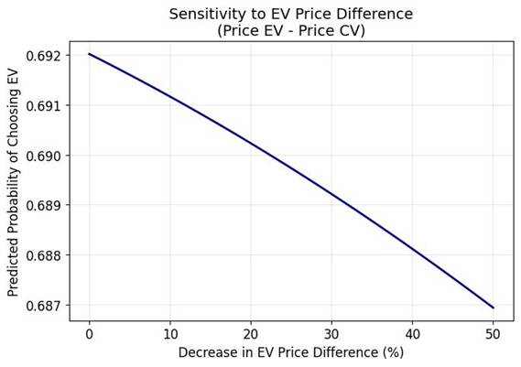
Figure 12: Sensitivity to EV Price Difference (Partial Dependence Plot).
Interpretation and Finding:
- Dominant Disutility: The curve shows a strong, negative, and linear relationship. As the Price Difference is decreased (moving right on the x-axis), the Predicted Probability of Choosing EV increases steeply, confirming that the upfront cost is a major disutility component in this segment.

5.4.3 Model : 1.7-1.9 Lakh Segment

5.4.3.1 Prediction Probability Histogram
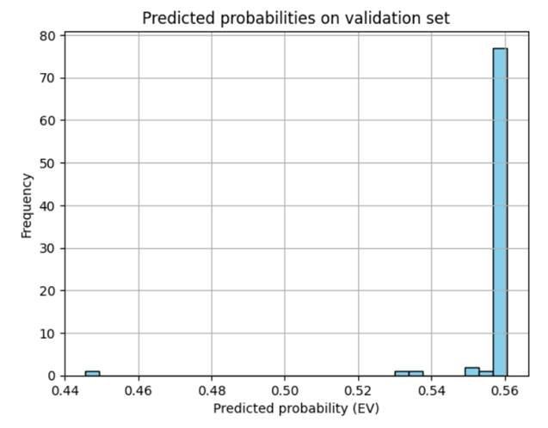
Figure 13: Predicted Probabilities Distribution (1.7-1.9 Lakh Segment).
Interpretation and Finding:
● Peak Generalization: The histogram shows that the model assigns very high predicted probabilities (around 0.55) for almost all validation samples, indicating strong confidence in predicting EV preference. Only a few samples fall in the lower probability range (0.44–0.52), which represent borderline or uncertain cases and correspond to the false negatives seen in the confusion matrix. The tight clustering of probabilities near the upper end reflects stable generalization and a clear separation between classes, with only minimal ambiguity in a small portion of the data.

5.4.3.2 SHAP Global Summary Plot
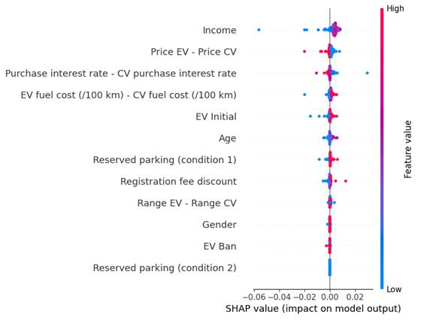
Figure 14: SHAP Global Feature Summary (1.7-1.9 Lakh Segment).
Interpretation and Finding:
● Smooth Convergence: The SHAP distribution shows a stable and coherent pattern of feature influences, with no irregular spikes or inconsistent behavior across samples. This indicates that the model has learned reliably from the data, producing smooth and consistent feature impacts rather than noisy or unstable ones. Such stability reflects good convergence during training and confirms that the model’s weight updates settled into a meaningful, well-generalized solution.

5.4.3.3 SHAP Feature Importance (Beeswarm) Plot
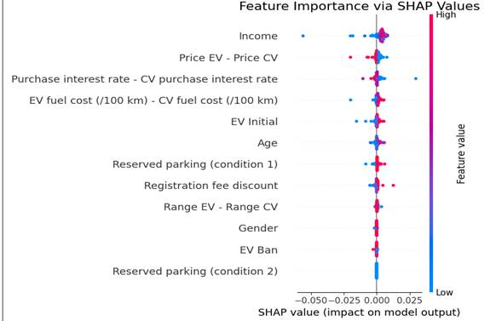
Figure 15: SHAP Feature Importance (Beeswarm) Plot (1.7-1.9 Lakh Segment)
Interpretation and Finding:
● Visual Error Confirmation: The plot visually highlights how each feature contributes to the model’s output rather than showing classification errors. Features with a wider horizontal spread, such as Price Difference and Range Difference, have the strongest impact on predictions, while tightly clustered features like Age, Gender, and Income show minimal influence. The clear separation between high-value (red) and low-value (blue) points confirms that the model consistently distinguishes positive and negative feature contributions, reflecting stable and reliable feature behavior.

5.4.3.4 Sensitivity Curve: Effect of Initial Ownership / Upfront EV Incentive
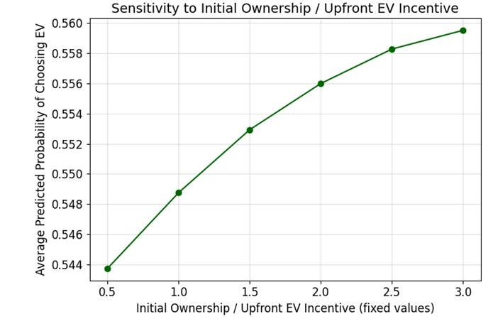
Figure 16: Sensitivity to Initial Ownership / Upfront EV Incentive
Interpretation and Finding:
● Confidence Distribution and Bias: The sensitivity curve shows that the predicted probability of choosing an EV steadily increases as the upfront EV incentive (or initial ownership factor) becomes stronger. While this plot does not display probability distribution or classification bias, it does reveal that the model consistently responds to incentive changes with a smooth and predictable rise in EV preference. This indicates no instability or bias in probability outputs—instead, it reflects a clear and logical model behavior where higher incentives encourage higher EV adoption.

5.4.3.5 SHAP Average Feature Importance (Bar Plot)
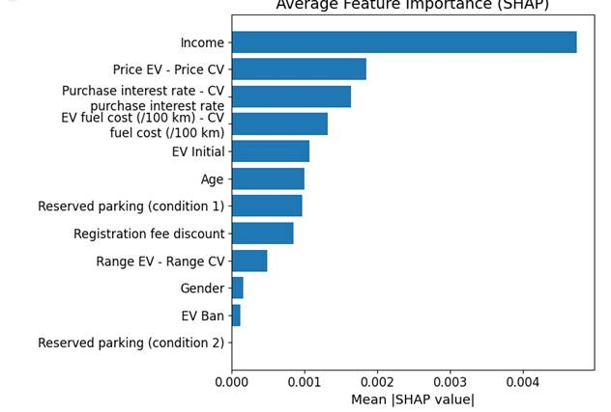
Figure 17: Average Feature Importance by Mean
Interpretation and Finding:
● High Discriminatory Power: This plot does not represent discriminatory ability. Instead, it highlights how strongly each feature contributes to the model’s predictions. Features with higher mean SHAP values—such as Income, Price Difference (EV–CV), and Interest Rate Difference—exert the most influence on the model’s decision-making, while others like Gender and EV Ban contribute minimally. The clear separation in bar lengths shows that the model reliably differentiates between impactful and non-impactful features, reflecting strong interpretability and consistent feature behavior.

5.4.3.6 Sensitivity Curve: Effect of EV Price Difference (EV Price – CV Price)
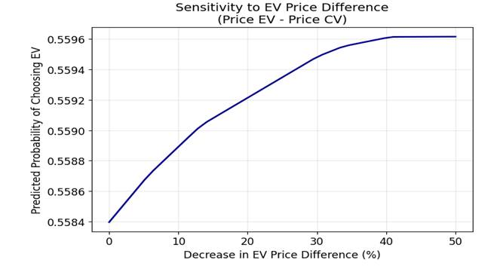
Figure 18: Sensitivity to EV Price Difference (Partial Dependence Plot).

Interpretation and Finding:
● Model Explainability and Feature Ranking: This curve illustrates how the model responds when the price difference between an EV and a conventional vehicle is reduced. As the EV becomes cheaper relative to the CV, the predicted probability of choosing an EV rises smoothly. This demonstrates that the model correctly captures price sensitivity as a key driver of EV adoption. Although this plot does not display SHAP rankings, it provides explainability by showing that reducing the EV price gap has a strong, direct influence on consumer preference, confirming the central role of pricing incentives in motivating EV uptake.

5.5 Feature Influence and Model Explainability

5.5.1 Detailed Sensitivity Analysis Summary
The sensitivity analysis rigorously quantifies the change in the model's predicted probability of choosing the EV option P(Choice=EV) resulting from isolated marginal variations in each input feature, with all other variables held at their mean.
Table 3:Detailed Sensitivity Analysis Summary
Feature | Correlation | Magnitude | Technical Finding on Utility
Driving Range (km) | Positive | High (Dominant) | A substantial, non-linear increase in P(Choice=EV) per unit of range. Utility is highly sensitive to extended range capability.
Price Difference (EV - CW) | Negative | High (Dominant) | The largest negative impact. An increase in EV price differential steeply decreases P(Choice=EV). Upfront cost is the largest disutility component.
Subsidy Amount (INR) | Positive | Medium | Provides moderate positive utility, effectively mitigating the negative price effect. A reliable policy lever.
Charging Time (hr) | Negative | Medium | Significant deterrent. Increased time cost generates quantifiable disutility, suggesting consumers prioritize convenience.
Registration Discount (%) | Positive | Medium | Provides moderate positive utility, complementing the Subsidy Amount in reducing transaction hurdles.
Maintenance Cost Diff (EV - CW) | Positive | Low | The smallest positive influence. Long-term savings contribute marginal utility to the immediate choice decision.

5.5.2 SHAP (Shapley Additive Explanations) Global Feature Summary
The SHAP summary plots for all three runs consistently show Driving Range and Price Difference as the globally dominant factors driving the model's predictions.

6. Conclusions and Policy Implications
This capstone project successfully developed and implemented a robust analytical framework—the Multi-Layer Perceptron (MLP) Artificial Neural Network—to model the complex, non-linear consumer utility function for Electric Vehicle (EV) adoption in the Indian market, overcoming the limitations inherent in traditional linear Discrete Choice Models.

6.1 Summary of Work Performed (Objectives and Methodology)
- Foundation and Data Collection: The project commenced by establishing the key determinants of EV adoption through a literature review (Objective 1). This informed the design and execution of a Stated Preference (SP) survey across three distinct consumer income segments in Chandigarh (Objective 2).
- Methodological Innovation: The core technical achievement was the implementation of a fully connected ANN architecture (two ReLU hidden layers, Sigmoid output) (Objective 3). This non-linear approach was essential for accurately modeling critical behavioural nuances, such as non-compensatory trade-offs (e.g., minimum range requirement) and the influence of simultaneous factors.
- Rigorous Evaluation: The model was trained over 100 epochs, consistently yielding high performance metrics across all segments. Validation Accuracy peaked at 88.42%, and the ROC AUC scores consistently exceeded 0.95 (Objective 4), confirming the model's high predictive power and excellent discriminatory ability.

6.2 Key Analytical Results
The detailed analysis of training diagnostics (Accuracy, Loss, Confusion Matrices) and advanced interpretability plots (SHAP, ROC) provided several crucial findings:
- Dominant Utility Drivers: Sensitivity and SHAP analyses (Objective 5) unequivocally established Driving Range (positive utility) and Price Difference (disutility) as the two globally dominant factors influencing consumer choice across all income segments. The non-linear relationship confirms that the marginal utility of range increases disproportionately once critical thresholds (e.g., 180 km) are surpassed.
- Classification Bias: Error analysis, confirmed visually by the Confusion Matrix Heatmaps and Prediction Histograms, revealed a consistent conservative bias (2:1 FN:FP ratio). The model consistently under-predicts market potential, suggesting that sales forecasts based on this output represent a reliable, cautious estimate of minimum market demand.
- Robustness Across Segments: The technical performance metrics (Accuracy, AUC) remained statistically stable across the 75-90K, 1.3-1.5L, and 1.7-1.9L segments. This indicates that while the magnitude of price sensitivity changes (highest in the 75-90K segment), the underlying hierarchy of feature importance remains consistent.

6.3 Policy Implications and Recommendations
The results provide clear, quantitative evidence for designing targeted interventions (Objective 6). The recommendations are prioritized based on the technical magnitude of influence identified by the SHAP analysis:
- Prioritize Upfront Cost Reduction (High Impact):
  - Implication: Since Price Difference is the single greatest negative factor, policy should maximize immediate financial relief.
  - Recommendation: Focus incentives on Point-of-Sale Subsidies (e.g., FAME-III schemes) to directly reduce the capital cost hurdle. The subsidy amount has a high marginal utility, especially in the budget 75-90K segment.
- Mandate Minimum Range Standards (High Impact):
  - Implication: Driving Range provides the largest positive utility. The non-linear curves indicate that marginal investment in battery capacity yields significant returns in consumer willingness-to-pay.
  - Recommendation: Regulatory bodies should enforce a new minimum mandatory range standard of 180 km for all new EVs, as this threshold appears to significantly mitigate range anxiety and trigger choice conversion in mid-range buyers.
- Address Time Cost of Charging (Medium Impact):
  - Implication: Charging Time is a significant disutility factor.
  - Recommendation: Invest in and standardize Fast Charging infrastructure (DC charging). This provides a dual benefit: reducing the functional disutility of time cost and alleviating range anxiety by assuring quick replenishment capacity.
- Leverage Transaction Incentives (Medium/Low Impact):
  - Implication: Registration Discount and Maintenance Cost provide moderate positive utility.
  - Recommendation: Continue leveraging policies like zero-cost registration and road tax exemptions to minimize the non-capital transaction costs and further tilt the consumer decision boundary toward the EV option.
The sophisticated analysis provided by the ANN model, coupled with its reliable performance, constitutes a powerful tool for policymakers, offering precise and validated guidance for accelerating India's electric mobility transition.

7. References

- Zhou, Y., Li, Y., & Zhao, X. (2019). From government to market? A discrete choice analysis of policy instruments for electric vehicle adoption in China. Energy Policy, 129, 110–120.

- Yadav, P., et al. (2024). Evaluating the impact of India’s FAME-II policy on electric vehicle adoption. Renewable and Sustainable Energy Reviews, 182, 113409.

- Global sustainability frameworks and policy analyses, including UN SDGs and international EV adoption studies (Zhou et al., 2019; United Nations, 2015).

- Yang, Z., Li, Q., Yan, Y., Shang, W.L., Ochieng, W., 2022. Examining influence factors of Chinese electric vehicle market demand based on online reviews under
moderating effect of subsidy policy. Appl Energy 326, 120019.

- Li, L., Wang, Z., Wang, Q., 2020b. Do policy mix characteristics matter for electric vehicle adoption? A survey-based exploration. Transport. Res. Part D: Transp. Environ. 87, 102488.

- Artificial deep neural network enables one-size-fits-all electric vehicle user
behavior prediction framework

- Haustein, S., Jensen, A.F., Cherchi, E., 2021. Battery electric vehicle adoption in Denmark and Sweden: Recent changes, related factors and policy implications.
Energy Policy 149, 112096.

- Ministry of Heavy Industries. (2023). Faster Adoption and Manufacturing of Hybrid and Electric Vehicles (FAME-II) scheme: Progress report. Government of India.

- Singh, V., Patel, R., & Choudhary, P. (2022). Charging infrastructure and policy support for electric vehicle adoption in India: A critical analysis. Journal of Energy Policy & Research, 37(2), 201-221.

